The following is taken from this document:
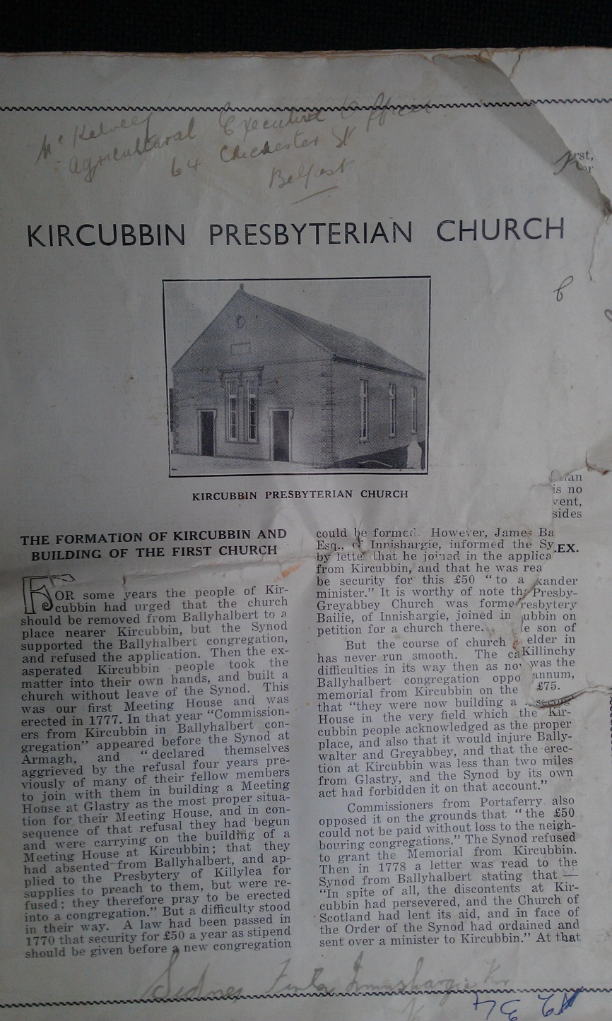
Digitised by Thanael, 2013
Kircubbin Presbyterian Church
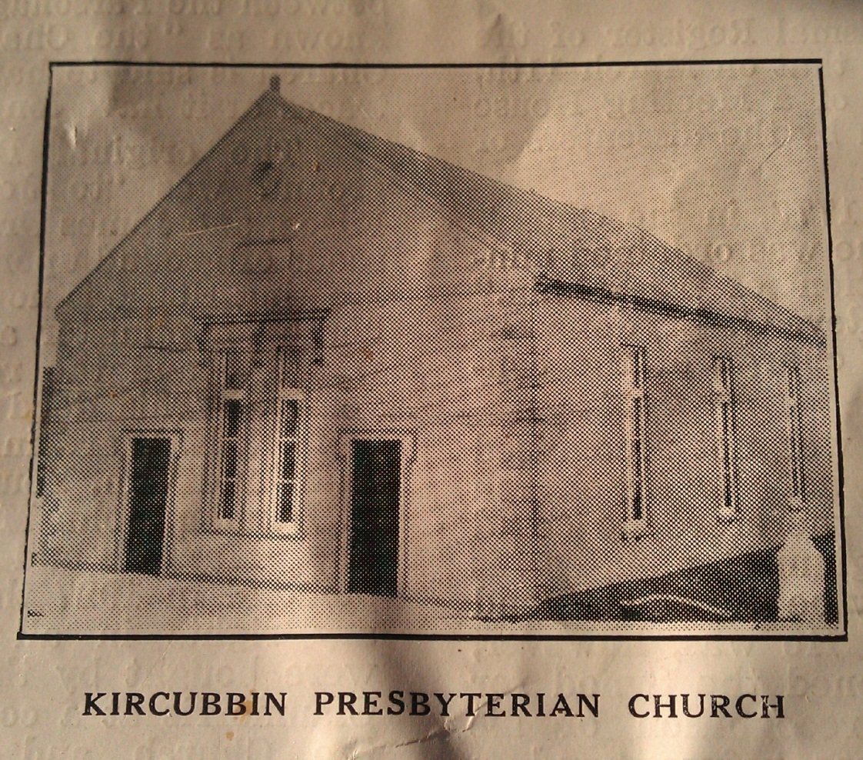
The formation of Kircubbin and the building of the first church
For some years the people of Kircubbin had urged that the church should be removed from Ballyhalbert to a place nearer Kircubbin, but the Synod supported the Ballyhalbert congregation and refused the application. Then the exasperated Kircubbin people took the matter into their own hands and built a church without leave of the Synod. This was our first Meeting House and was erected in 1777. In that year “Commissioners from Kircubbin in Ballyhalbert congregation” appeared before the Synod at Armagh, and “declared themselves aggrieved by the refusal four years previously of many of their fellow members to join with them in building a Meeting House at Glastry as the most proper situation for their Meeting House, and in consequence of that refusal they had begun and were carrying on the building of a Meeting House at Kircubbin; that they had absented from Ballyhalbert, and applied to the Presbytery of Killylea for supplies to preach to them, but were refused; they therefore pray to be erected into a congregation.”But a difficulty stood in their way. A law had been passed in 1770 that security for £50 a year as stipend should be given before a new congregation could be formed. However, James Bailie Esq., of Innishargie, informed the Synod by letter that he joined in the application from Kircubbin, and that he was re[missing-please see appendix] be security for this £50 “to a [missing] minister.” It is worthy of note that [missing] Greyabbey Church was formed [missing] Balie, of Innishargie, joined in [missing] petition for a church there.
But the course of church [missing] has never run smooth. The ca[missing] difficulties in its way then as now [missing] Ballyhalbert congregation oppo[missing memorial from Kircubbin on the grounds that “they were now building a Meeting House in the very field which the Kircubbin people acknowledged as the proper place, and also that it would injure Ballywalter and Greyabbey, and that the erection at Kircubbin was less than two miles from Glastry, and the Synod by its own act had forbidden it on that account.”
Commissioners from Portaferry also opposed it on the grounds that “the £50 could not be paid without loss to the neighbouring congregations.” The Synod refused to grant the Memorial from Kircubbin. Then in 1778 a letter was read to the Synod from Ballyhalbert stating that—“In spite of all, the discontents at Kircubbin had persevered, and the Church of Scotland had lent its aid, and in the face of the Order of the Synod had ordained and sent over a minister to Kircubbin.” At that time Kircubbin was only the name of a townland; the town did not exist until after the year 1790, from which year it has developed into the town as we now know it.
The first minister of Kircubbin 1778-1817
In the old Baptismal Register of the church it is recorded that on March 11th, 1777, the foundation of a Meeting House was laid at Kircubbin by the dissenters of that congregation.
“On March 3rd, 1778, in the church of Lauder, Mr. Brydone was ordained minister of the congregation of Kircubbin.” And “on April 26th Rev. G. Brydone entered on the pastoral charge of the congregation.”
But Mr. Brydone was not recognised by the Synod of Ulster, nor was his church under their care, and therefore he could not partake of the Regium Donum, so his total income would only be the £50 stipend promised in his Call. He was, however, not daunted, and petitioned the Synod for the reception and the recognition of his congregation. This was refused and a letter was sent from the Synod to the Church of Scotland complaining of “the conduct of the Presbytery in sending Mr. Brydone to officiate in part of the Parish of Ballyhalbert, calling themselves Kircubbin.”
[missing] that the Assembly in Edinburgh [missing] was to acknowledge their mistake [missing]ing the call a regular one, and [missing] that in future they would avoid [missing]ency to interfere in the peace of the Synod.
Mr. Brydone, however, retained his [missing]n, and during the four succeeding [missing] supplicated that he and his congregation should be received under the care of the Synod. Finally in 1783 at Lurgan it was resolved to receive Mr. Brydone – “though his settlement was irregular; yet in consideration of the goodness of his private character the Synod received him as a matter of favour.” He was also “allowed to become a member of any Presbytery then in the bounds of the Synod that would receive him.”
Thus the long controversy ended. But since the local Presbyteries had opposed him, he applied to the Belfast Presbytery, and was received by it, and for many years he and his congregation were attached to that Presbytery. Thenceforward Mr. Brydone received in addition to his stipend of £50 the Reguim Donum amounting to about £20.
Kircubbin
The name has no connection with Kirk. It is a corruption of Kilcooby, or Kilcubyn. About the year 1300 A.D. Wm. De Mandeville gave the townlands of Kircubyn and Ballymullen to the Order of St. John the Baptist in Down. A field between the Parsonage and Lakeview was known as “the Chapel Field.” Cooby’s Church is said to have been here, but all traces of it have long since disappeared.
The original deed of the Church ground was “to John Warnock, James Filson and James Orr as Trustees for three roods of ground upon which the Dissenting Meeting House is now built, and a retiring house for minister and elders.” The cost was 5/-, and the rent 6d, payable half yearly. This deed was replaced by one from R. E. Ward in 1877 to G. Finlay, D. Shaw and Wm. Young as trustees. In 1905 R. Donnan, John Muckle, Wm. J. Woods, Thos. Maxwell and R. McKibbin were appointed. In 1927 the rents and reversionary rights in all the church property were bought by the Trustees from Lady Clanmorris at a cost of £67, and in 1933 the Church and Manse property was vested in the Education Board of the Ards Presbytery.
The cost of building the church is recorded in detail in the old Minute Book as – £212 15s 9d.
Hearse and Palls – £13 13s 8d.
Retiring House – £20 10s 2½d.
Carriage House and Gate – £7 8s 7d.
Cups and Tankards – £3 9s 10½d.
Total - £272 4s 4d,
towards which James Bailie gave £50, and Rev. Roger Blackhall, Vicar of St. Andrews, £5 13s 9d. It is probably after him Blackhall Street is named (though some say it is so named because of its connection with the “Black” Friars).
During his ministry Mr. Brydone baptised 1,215 children – rather more than 30 each year – a great contrast to present-day numbers. The Synod has not recorded much about him except his attendance, which was regular, though the distance to Belfast and other places where the Synod met was much more difficult in those days than crossing to America to-day. In spite of the irregularity of his appointment he must have been highly esteemed by his brethren as his name was one of the few mentioned for the Moderatorship of Synod. The 20 years following his settlement were years of great unrest and dissatisfaction amongst the peasant class in Ulster, until in 1798 the Rebellion broke out, involving some Presbyterian minsters, one of whom, Rev. Porter, of Greyabbey, was hanged outside his own gate more from the personal spite of Lord Castlereagh (who changed the politics and the religion of the Stewarts) than because of any acts of treason. In the Report of the Belfast Presbytery, 1799, it is stated that "Mr. Archibald Warwick who was under the care of the Presbytery (as a student for the Ministry, or as a Probationer), having been found guilty of treason by a military tribunal was executed at Kircubbin in the month of October, 1798. He was attended and comforted in his last hours by Mr. Brydone.” The old oak table upon which young Warwick was laid out is still preserved in the Manse premises. Mr. Brydone must have been a shrewd and judicious man to escape the obloquy which many others endured in those exciting days. He seems to have taken no part in political affairs, but to have discharged his pastoral duties with zeal and ability to the satisfaction of his people. He owned a farm at Dunavelly, near Portaferry (it was probably given to him by Mr. Bailie, who owned Dunavelly at the time), performing his journeys on horseback. He died there on 5th August, 1817, the Belfast Presbytery reported that “Rev. G. Brydone being unable through age and infirmity to discharge his pastoral duties requested the Presbytery to allow his congregation to choose an assistant and successor.” Before that could be carried out he died on 5th September following, leaving neither widow nor family. It was probably a brother of his who died at Dunavelly in 1824, aged 74 years, and was buried near Mr. Brydone in Kircubbin. This inscription can be traced on this our first minister’s gravestone in the churchyard – “Underneath lies the body of the Rev. George Brydone, late minister of the Presbyterian Church of Kircubbin. He was ordained to the pastoral charge of the congregation by the Presbytery of Lauder, Synod of Kelso, Scotland, March 3rd, and commenced his ministerial labours April 26th, 1778, and departed this life September 5th 1817, aged 70 years.”
The Records of the Church of Scotland say that George Brydone was “a native of Lauderdale, educated at University of Edinburgh; licensed by Presbytery of Earlston; ordained (by same Presbytery) to Kircubbin in 1778, died 6th September, 1817.”
In the “Belfast News-Letter” of 9th September 1817, the following notice is taken of his passing away—“Died a few days ago at Dunavelly, nearly 70 years of age, the Rev. George Brydone, the first, and during 40 years Presbyterian minister of the congregation of Kircubbin. He was invited from Scotland, being recommended by the Rev. Dr. McKenzie, of Portpatrick. No human character can be supposed to be altogether without spot; but of him it may be observed, that in his pastoral duties he was exemplary correct; his manners were simple, and his character irreproachable. His discourses were plain and unadorned; so much so that he was seldom known to use words of more than two syllables, except when it became unavoidable. The greater part of the week he generally spent in preparation for the pulpit; and latterly his time was almost entirely devoted to the perusal of, and meditation on, the scriptures of truth, which the writer of this article has heard him more than once declare, were under trial, the only certain grounds of consolation and support. From his uninterrupted habits of sobriety and seclusion, he succeeded in realizing a considerable property, which some think in the care of a clergyman should never be attempted.” There is no record left as to where his wealth went, and what other relatives he had besides the brother left at Dunavelly.
The second minister – Rev. Alex. McEwen, 1817-1839
He was succeeded by Rev. Alexander McEwen, a licentiate of the Newry Presbytery, who was ordained by the Presbytery of Belfast as the minister of Kircubbin on 16th October, 1817. He was the son of John McEwen, of Derryboy, an elder in Killyleagh, who is buried in Killinchy Meeting House Green. His stipend was the same as his predecessor, £50 per annum, and Royal Bounty, which was now £75.
In 1820 he married Sarah, second daughter of Hugh Hays, of Ballymacreely. There were several daughters of this marriage, one of whom married in 1840 Dr. R. Hays, of Ballymacreely, after whose death she married Dr. Priestly. Another daughter became Mrs.. C. F. Johnston, who at her death left a bequest for keeping her father’s grave in order.
Mr. McEwen and his family lived at Lakeview. Whether it belonged to him, and later to his daughter cannot be said for certain, but it probably did.
Building of a schoolhouse
It was during his ministry the school house was erected. In the early days the only school outside Newtownards in the Ards was one maintained by the Earl of Clandeboy at Ballyhalbert. As a Scotsman and a scholar James Hamilton would encourage learning. He himself was one of the first two Fellows of Trinity College, but other things had to be done, and education made slow progress. As in other places, it was probably carried on by itinerant schoolmasters, but in 1829 a school was established in Kircubbin under the joint managership of Rev. F. Lascelles, Vicar or St. Andrews, and the Rev. Alexander McEwen, the Presbyterian minister. A Deed of 28¾ perches of ground was conveyed to them for ever by Robert Ward on 15th September, 1830, as trustees and managers at a cost of 5/- and an annual rent of 1/-. The Schoolhouse had then been built.
It was attended by the children of all religious denominations up to the year 1870, when a school was started at Tubber. From that date, Kircubbin School was managed solely by the Presbyterian minister, and kept in order by the committee of that Church. When the Education Board of the Ards Presbytery was formed, Rev. Hawthorne transferred the school to their care as Trustees. When in 1887 the Roman Catholic children were withdrawn to Blackhall St. School, the old school was attended chiefly by the children of Presbyterian parents. Mc. McEwen passed away in 1839.
On his gravestone in Kircubbin Green the following inscription can be read with difficulty as to a few dates – “Erected by his children to the memory of the Reverent Alexander McEwen of Kircubbin. He was ordained to the work of the ministry on the 10th of October, 1817, and finished his course on the 29th of January, 1839, aged 51 years. Also to the memory of their mother, Sarah McEwen, alias Hay, who departed this life eleven days before her husband, viz., on the 19th January, 1839, aged 42 years. Here are also interred the bodies of two of their sisters, viz., Mary Ann, who departed this life on the 28th November, 1827, aged two years, and Jane, who departed this life on the 15th April 1835, aged twelve years. On the 22nd December, 1848, Sally, their youngest sister, died in the 12th year of her age. Catherine Ferguson Johnson, daughter of the said Rev. Alexander McEwen, born 16th July 1828, died 8th April, 1877.
The third minister – Rev. James Rowan, 1838-1877
James Rowan was born at Church Hill, near Rathfriland, in 1805. His father was a respectable farmer, and James was the youngest son, and the favourite of his mother, to whom he was deeply devoted, and to whom he owed that deep subdued piety which distinguished him through life. During his college course in Belfast he had a severe attack of typhus which laid him aside for some years, and left him with impaired eyesight. In fact in latter years he became quite blind.
He was ordained by the Presbytery of Bangor, 30th January, 1838, as assistant and successor to Mr. McEwen. Like many other good and learned men his worth was not at first recognised. No vacant congregation wanted him, and he would not canvas for their favour. Thus he was for a considerable time a Probationer, but once he secured a church he soon proved himself a minister of no mean powers. Indeed he was one of the most scholarly and successful ministers our church has ever produced. He was induced to be a candidate for a chair in the college, but after a day spent in Belfast with those who would have supported him he withdrew his name. No wonder!
Dr. Cooke described him as “a dungeon of learning.” His bent was towards Metaphysics and Ethics, but few had a better knowledge of the Classics and Hebrew, besides being able to enjoy French and Italian literature. He kept himself abreast of the latest thought by reading the best monthly and quarterly magazines. He is described as “a tall, straight man with broad shoulders, crowned by a head in harmony with those shoulders, which was covered with a rich growth of short, silvery hair in his latter years. He could not be called handsome, but his face when lit up by the fires within glowed and became soft and mirthful as a child’s. He led a quiet life, attending to his own simple business in his own efficient way.” In fact, he was one of those men who by their consecrated lives and energy in country and village congregations are the backbone of our Presbyterian Church and of the Kingdom of God upon the earth. He was a clerk of the Presbytery, and as such had few equals. “He could always come down without mercy on weaker brethren who only obstructed business by talking twaddle.” Rev. R. Jeffrey, who had been one of his pupils, described him as “the perfect type of Christian gentleman.” What better can be said of any man!
He married Helena Reid, daughter of Thomas Mayne Reid, for long years the senior clerk of Assembly, and sister of Cap. Mayne Reid, the novelist. She was a model minister’s wife, and is described by Mr. J. J. Shaw as “one of the most charming women” he had ever met. “Her mind was well nigh as clear and strong and cultured as that of her husband.” Not long after his settlement in the year 1840 the two Synods—the Synod of Ulster and the Secession Synod—were united in one General Assembly, consisting of 433 congregations. The Arian element in the Synod of Ulster having separated from it in 1829 there was no longer any reason for their remaining apart. Thus the church became strong to face the new and greater duties that lay in her path.
After this union the congregations connected with the Synod of Ulster in the Presbytery of Bangor (number 12) united with the Secession congregations in the Presbytery of Ards (numbering eight) to form the new Ards Presbytery in 1841. The first printed Report of the congregation is dated 1858. It was printed by the “Banner of Ulster” office and cost 12/-. A year’s candles for the church then cost 18/11½. In early years Wine for Communion was an expensive item. Six gallons each year at over £2! The Poor Box was in old days really a Poor Fund, for we find a list of some 20 men and women who received aid each year.
Being an educated man Mr. Rowan wished to use his knowledge for the education of others. So we can well believe that his sermons were the strong, massive thought of the week about the Scriptures, talked out to his people on the Sabbath day. Besides he used his talents during the week in teaching the higher branches of secular knowledge for pure love of his work. Mr. R. Jeffrey was one of his pupils. He became minister of Mallow, Greyabbey and Portadown, and in writing of Mr. Rowan in “The Presbyterian Churchman” placed him amongst “Our Presbyterian Worthies.” How is it we have no such writing to-day?
Another pupil was Mr. J. J. Shaw, who became Professor of Metaphysics in Magee College, afterwards Professor of Political Economy in Dublin University, County Court Judge in Kerry, and finally Recorder of Belfast.
A third was Miss Welsh, daughter of his life-long friend at Granshaw. She passed through Cambridge University, securing Tripos Honours in Classics, and became Principal of Girton College, Cambridge. A sister of hers became wife of a Magee College Professor.
Besides these many others in the congregation must have benefited greatly by the rich conversation, his teaching on the Sabbath day, and by the impress of his strong personality and consecrated life. He lived for some years in Innishargie House, which then belonged to the Young family.
But he had an outlook for the future, and in 1860 he secured from the Hon. R. E. Ward the New Market House and Brown Linen Hall of 1837, and ground at the rere for the purpose of erecting a Manse. The trustees were John Welsh, Wm. Shaw, John Muckle and R.O. Young. The Manse was in due time built and corresponds to the big ideas of the man, especially the Dining Room, which was used as his Schoolroom. No record remains of the cost, but a debt remained for some years, £100 of which was paid when the new church was built, and another £100 in 1870. The old Market House Bell was removed to the church grounds, and has called the people to worship ever since, over a period of some 76 years.
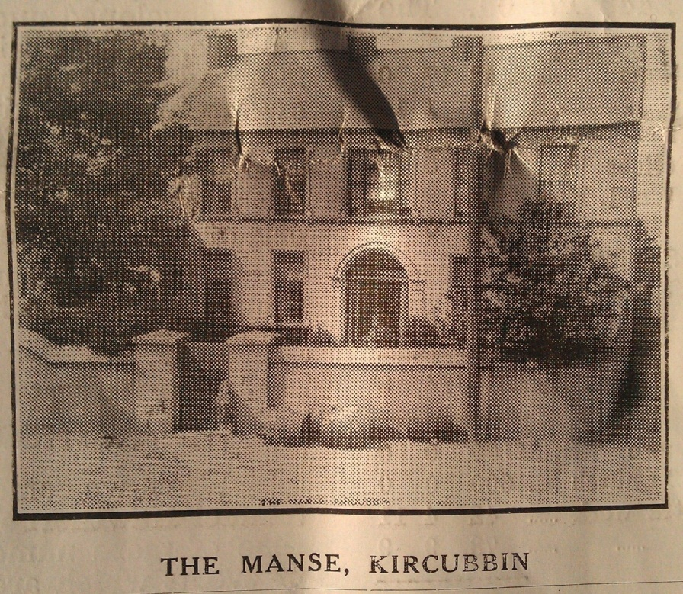
Another property known as the Black Entry was conveyed by Mr. John Maxwell in 1872, and became part of the Manse property and grounds.
The new church
The next great venture of Mr. Rowan was the rebuilding of the church. For many years it was tottering to its fall, but he refused to go begging for what he considered the duty of the congregation itself – “Kircubbin was never dragged through the mire, and the dust of a begging expedition by reason of its own poverty stricken spirit, or by the moral cowardice of its minister.” The church was, however, built, and the graveyard enclosed free of debt. To enable it to be so opened Mr. Rowan gave a year’s stipend, and the congregation added an equal amount, thus the feat was accomplished.
An account of this expenditure and the contributions of the members appear in the 7th Annual Report, 1864. From it we gather that Mr. Rowan contributed £53 5s 0d, which with the congregational subscriptions amounted to £443 17s 0d. The details are –
To Congregational Subscriptions £443 17s 0d
Money in hand previously 87 1 10
Interest on Cash in Bank 9 10 10
Receipts at Opening Services 106 6 0
Subscription from R.E. Ward,
Esq., Bangor Castle 150 0 0
Amount subscribed by Session and
Committee to clear off remaining debt 19 0 0
Total £815 14s 8d
By Cash paid to building Manse £100 0s 0d
Contract for Building of Church 600 0 0
Paid Contractor for extra work 42 4 11
Additional Expenses 73 9 9
£815 14s 8d
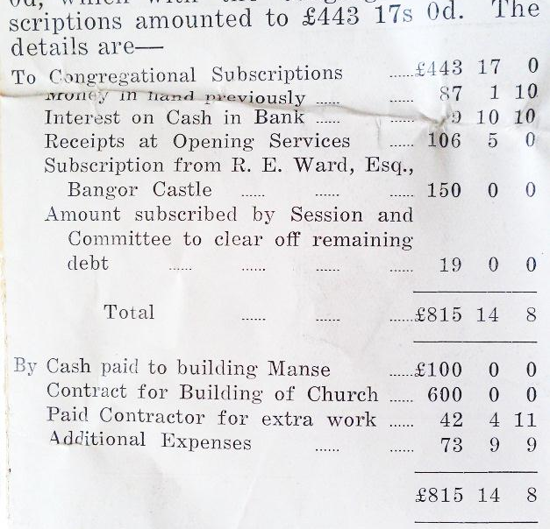
During the 31 years of his ministry Mr. Rowan baptized 522 children.
In 1868 his eyesight entirely failed, and on 1st June 1869, Mr. Samuel Hawthorne was ordained as his assistant and successor, and on 5th December, 1877, Mr. Rowan passed away. His wife survived him till 9th March, 1879. The dust of both now lies in the graveyard beside the church where he exercised such a gracious, and faithful ministry.
I am indebted to Mrs. Moore, a niece of Mrs. Rowan’s, and wife of Rev. H. H. Moore, late of Markethill, for the following—“I don’t think my uncle Rowan ever had a photo. My memory of him is that of a very tall man almost blind, led about by a very tiny little lady who was my aunt. I don’t think that he ever wrote anything; but the latest in literature was always to be found in their Manse. When his sight failed, my aunt, who was a great reader, read aloud by the hour everything of current interest.”
In later years he made any of his old pupils who called read to him in the same way.
As you pass up the church you will be struck by a beautiful mediaeval Brass of Gothic pattern, set in richly carved oak. Round an open Bible there runs a ribband with the words of the Psalmist—“Thy servant did meditate in Thy statutes.” And upon the body of the Brass the following most beautiful tribute to his memory—
“In memory of the Rev. James Rowan, a man whose rare qualities of mind and character were fully known only to the few who knew him best and loved him most; this tablet is placed here by some of his old pupils and friends whose minds were developed under his wise and tender nurture, whose lives were deeply influenced by his counsel and example, who owe to his suggestive and stimulating conversation many lofty lessons of moral and spiritual wisdom, and who cherish as one of their most precious possessions the memory of his goodness, wisdom and love.” Who of us would not desire or wish something like that to be recorded of us when we are gone?
The Fourth Minister – Rev. S. Hawthorne, 1869-1924
When we come to the ministry of Rev. Samuel Hawthorne we are dealing with a time of more numerous records, and also of events which are within the memory of many yet alive, so that the difficulty is to give a lucid account without being too prolix or too brief. Samuel Hawthorne was born in the year 1842 in the centre of Co. Down. He was the second son of the family of six sons and two daughters of William Hawthorne, a respectable farmer, and rigid covenanter, who till he died at the age of 92 years repeated every Sabbath morning the Prologue to the Solemn League and Covenant at Family Prayers. Samuel graduated in the old Queen’s University from Belfast in 1864, and took his Theological course at Assembly’s College, Belfast. He was brought up in connection with Ballyroney Church, and licensed on May 5th 1868, by the Rathfriland Presbytery. On the 1st June, 1869, he was ordained in Kircubbin. The stipend promised him was £60 with increase. Shortly after his ordination Mr. Rowan, who still took an interest in the congregation and attended the meetings of Committee, raised £170, which more than cleared off the debt of £100, due to Mrs. McKelvey and Captain Herron against building of the Manse.
For some years there was difficulty in raising the qualification towards the new Sustentation Fund started in 1870, when the Irish Church Disestablishment Act became law and the annual payments to Irish Presbyterian ministers by the state ceased. However, Mr. Rowan by his wise counsel and by his energy succeeded in getting the amount raised during the years that were granted to him.
In the year 1873 when on a visit to Rev. J. C. Aston, Missionary to the Jews at Hamburg, Mr. Hawthorne met Miss Alice Peterson, daughter of a Yorkshire merchant, whose connections with the Continent led him to settle in that city, and who joined Mr. Aston’s church and became an elder. In 1874 he returned to Hamburg and married Miss Peterson. In the year 1881 the Committee numbered 31; besides numbering 21 to look after the interests of the Sustentation Fund. In that year a new water supply was procured for the Manse. Who shall say that a large Committee effects nothing?
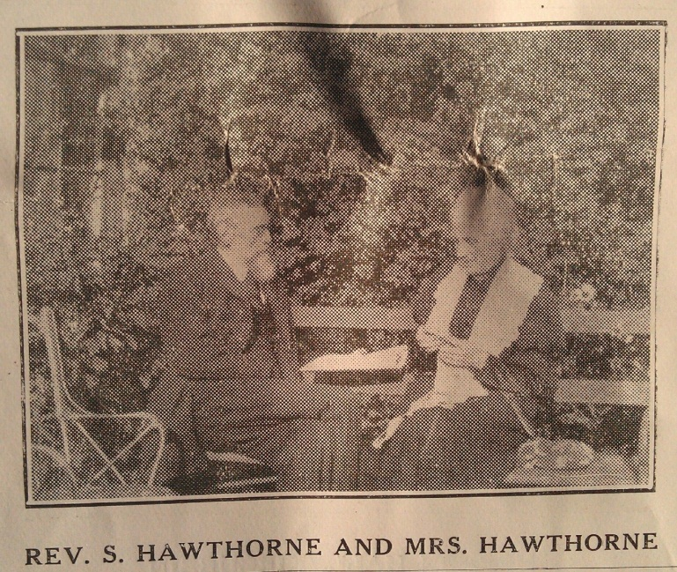
The Teacher’s Residence
It was a considerable handicap to teachers in the days when their salaries were small to pay the rent of a suitable house. The consequence was that married men sought a school with residence attached. To obviate that Mr. Hawthorne decided to provide a Residence, and in 1891 in a field secured from Mrs. J. Maxwell the building was erected at a cost of £280, of which £250 was received from the Board of Works.
In 1894 on the 25th anniversary of his ordination Mr. Hawthorne was presented with an Address, and Cheque for £70.
Leaders of the Praise Service
The first mention of a Leader is in the year 1862 when Mr. McCaw was paid £6 “for singing.” This was afterwards increased to £10 per annum.
Mr. Allen succeeded him in 1870, and continued to receive the same remuneration.
From the year 1873 Miss Morgan conducted the choir, and received £6 per annum for her services.
After 1878 Miss Johnston led the Praise and was paid £5, and in 1883 Miss Harris was appointed and received an equal amount. For many years after that date Mr. Thomas Maxwell trained and led the choir, and in 1895 was presented with a Barometer, Bookcase and Books in recognition of his voluntary services. He continued voluntary leader till his retirement in 1922, when he was presented with an address surmounted by a photo of himself and choir, and surrounded by views of local places of interest. He had then been over 40 years connected with the choir, and for the greater part of those years he had been responsible for its training. For some years after his resignation Mr. James Glover acted as choirmaster.
One reason for the efficiency of the choir was that for several years Mr. Curran taught a music class for the young for which the Committee provided most of the funds.
Erection of the Herron Hall
A Hall is very necessary for many of the activities of a Church. This was felt by Mr. John Herron, of Liverpool, who erected in 1897 the Herron Hall in memory of his wife. A Memorial Tablet to her is placed on the West Gable, and one to Mr. Herron was added on his death. The cost was £402 15s 3d. The details of outlay are as follows:
J. Herron £271 9s 3d
Subscriptions 29 6 0
Collection at Opening 51 15 3
Concert and Lecture 35 4 9
Congregation Funds 10 0 0
Total: 402 15 3
Builder 351 0 0
Architect 6 10 0
Furniture 37 12 0
Other Expenses 7 13 3
Total: 402 15 3
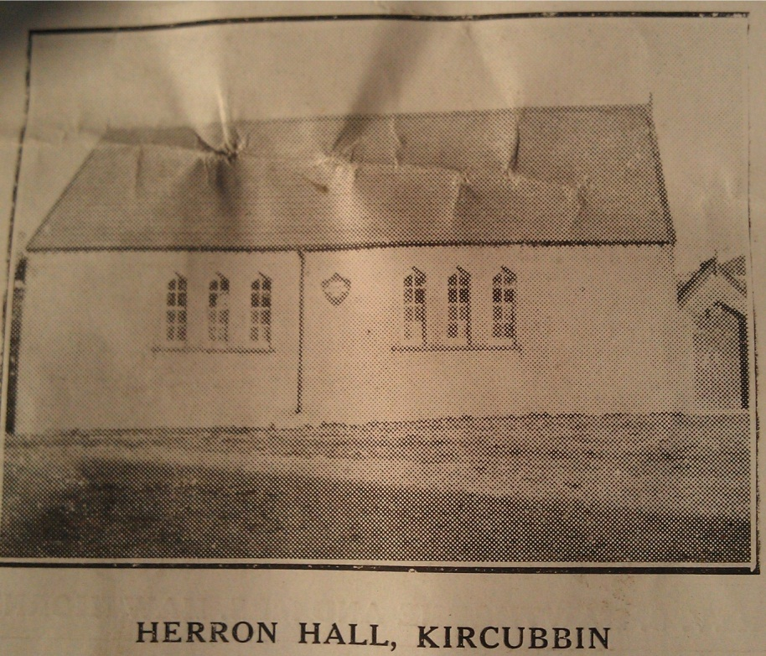
Gifts of a Piano, Lamps, Bookcase and Books were presented by Mrs. T. Shaw, Mr. S. Young, M.P.; Mr. Thos. Shaw, Judge Shaw, and Mr. Adam Speers.
From time to time considerable sums were expended on repairs to Church, Manse, Schoolhouse, Teacher’s Residence and Sexton’s House, details of which are given in the Minute Book of the Committee.
Since the school was build there have been many distinguished teachers, and to them the community owes more than can ever be estimated.
Adam Speers, B. Sc., who married Miss Shaw, and who became Principal of the Sullivan School in Holywood, was a teacher of remarkable gifts, as was also James Glover, who was a great Mathematician
Sextons
A word is surely due about the sextons, to whom members owe so much of their comfort.
From the year 1862 till 1906 Mr. David Boyd performed these duties, receiving 7/6 per quarter, increase to 10/- in 1870.
In 1906 Mr. John Weir was appointed to assist him, receiving £1 per year. His remuneration was increased from time to time, and at present amounts to £12 per year.
Mrs. Hawthorne died in 1912, and is remembered as a most winsome and lovable woman by the people.
In the same year Mr. Hawthorne, who doubtless felt her loss and the strain of advancing years, retired, and for a time went to live at Helen’s Bay. On the outbreak of the Great War he took charge of Ardglass during the minister’s absence with the troops. Subsequently he went to Edinburgh where his daughter was in training. He died there in 1924. In the course of his ministry he received Calls to Portaferry and Bangor, both of which he refused. He was a man of one church and gave himself to it most heartily. In his earlier days he was a strong supporter of Tenant Right, but he could not follow Gladstone in 1885 in his Home Rule policy, and was selected to speak on the Unionist platform in the North of England and Scotland.
At one time there was an attempt made to extend the Belfast and Co. Down Railway to Portaferry. Mr. Hawthorne was one of the leading opponents of this proposal, as he considered it would have involved the levy of an unsupportable rate not only on the Ards but on the whole County. Owing to the opposition raised the sceheme never materialised, and the rate-payers have reason to be grateful for his foresight, for what a White Elephant a railway would be in the Ards in these days!
During his active ministry of 43 years Mr. Hawthorne baptised 620 children and performed 112 marriages.
The Assembly’s Memorial Record of 1925 says: -- “Mr. Hawthorne was a man characterised by great intellectual ability; his sermons were always delivered with much forcefulness, and highly appreciated by the members of his congregation. In the discharge of his pastoral duties he was most attentive, kindly and sympathetic. He took no prominent part in the business of the Church Courts, his chief concern being his parochial work. He was a most faithful and efficient minister, highly esteemed by all who knew him, and rendered excellent service to his Church during his long ministry.”
Several distinguished people were connected with the congregation during the ministry of Mr. Rowan, and that of Mr. Hawthorne. Besides those already mentioned – Judge Shaw, Miss Welsh, Adam Speers and James Glover – there were – Sam Young, M.P. for Cavan, the ardent and convinced Home Ruler in the Imperial Parliament. John Shaw, of Indianapolis, who welcomed many Kircubbin young men to the firm of Kingan & Co. Captain J. Herron, part-owner of the Laird Line of Sailing Ships, Liverpool, and Sir Wm. Maxwell, Indian Civil Service, now retired.
Rev Charles Henry Hunter is the fifth minister, 1913-
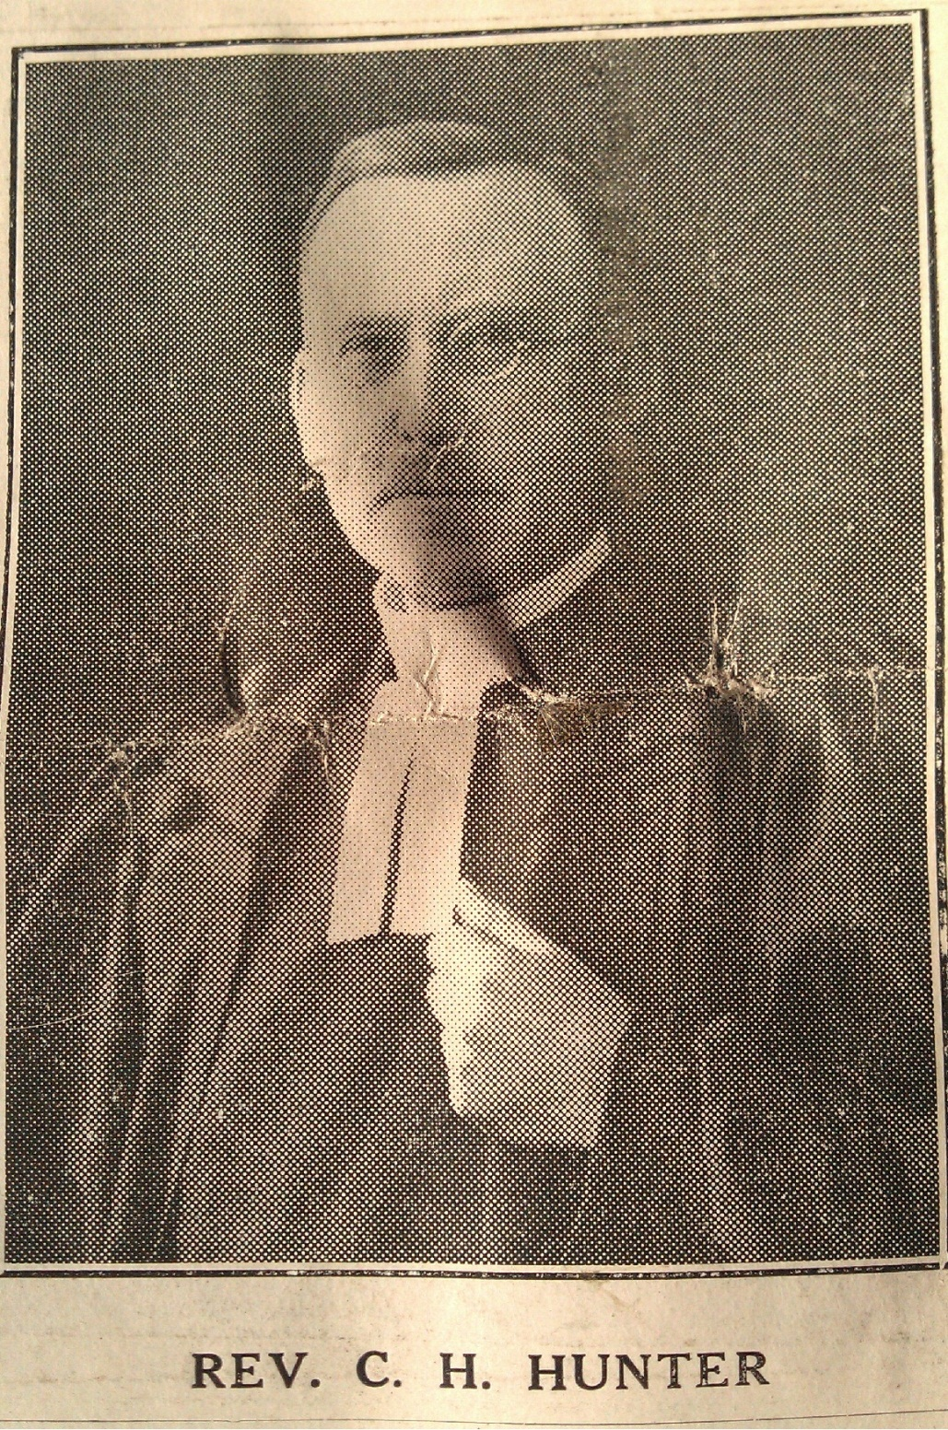
He was born at Aughnahoo, Castlederg, Co. Tyrone, brought up in connection with Killeter congregation, Donegal Presbytery; attended the local National School and Castlederg Intermediate School, from which he passed to Queen’s College, Galway, where he was Senior Scholar in Ancient Classics. He graduated in the Old Royal University and took his Theological Course in New College, Edinburgh for two years and the final year in Assembly’s College, Belfast. He was licensed by the Donegal Presbytery 2nd May, 1896 and ordained in Aughentain, Clogher Presbytery, on 4th January 1898. He resigned that charge on 1st September 1902, on his appointment by the Mission Board to work in the Colony of South Africa. Whilst there he organised the congregation of Aliwal, North, Cape Colony, where by his exertions a church was built. Whilst in Cape Colony he was married April 19th 1904, in the Gardens Church, Capetown, by Rev. J. J. McClure, to Martha, daughter of Thomas Smyth, Ballyjamesduff, Co. Cavan, and sister to the late Rev. Wm. Smyth, Mountmellick. Resigning his congregation in 1906 he returned to Ireland, was received under the Assembly’s care, and was installed on 9th October, 1907, by the Armagh Presbytery in Cladymore. After remaining there some years he received a call to Kircubbin, and was installed 4th March, 1913, as assistant and successor to Rev. S. Hawthorne. As soon as the Manse was renovated he and his wife and their only child Gladys made it their home. In the first year of his ministry in Kircubbin, the old stoves which only partially heated the church, causing more smoke than heat, were replaced by the more efficient hot water system of Messrs. Musgrave & Co., at a cost of £64.
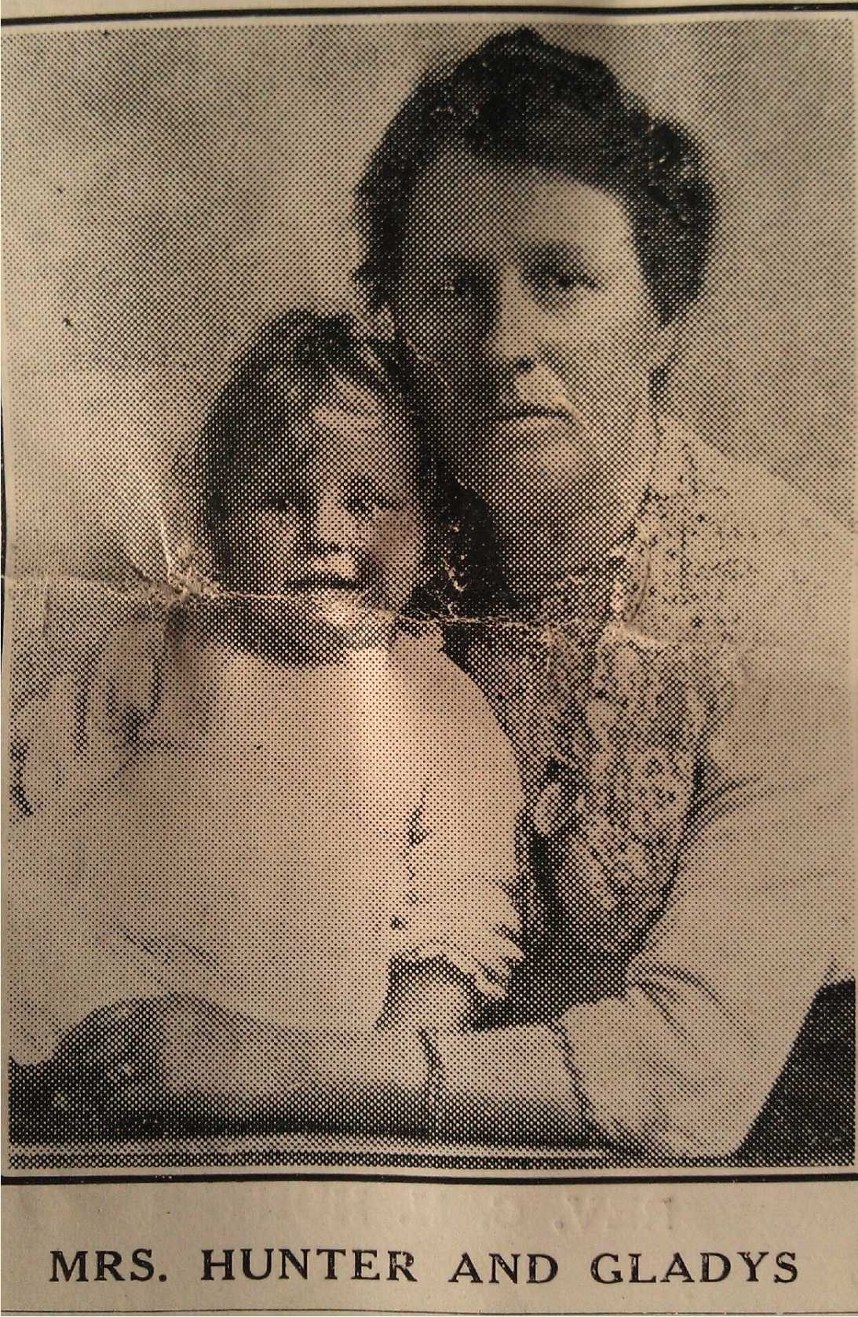
The Great War
The early years of this century will always be associated with The Great War (1914-1918), and for Irish people with the Irish Rebellion and the formation of separate Governments for the Irish Free State and the Six Counties of Northern Ireland. During those war years there is nothing outstanding to record concerning congregational life save the long drawn out agony of those who had boys at the front, and the stringency in regard to food and light. In the year 1916, however, on the eve of his departure to take up his residence in London, Mr. Thomas Shaw, our Senior Elder, was presented with an Illuminated Address as a token of the many valuable and faithful services he had rendered the congregation during his long life amongst them, for almost 40 years of which he had been an Elder.
In 1918 after his recovery from a severe illness Mr. Hunter was presented with a Wallet of Bank Notes, and later on the ladies also presented him with a Cassock and Gown, and Travelling Case.
When the War ended a Marble Scroll was placed in the Church in memory of the six young members who gave their lives, and to the honour of the 26 others who served. Upwards of £70 was handed to the Minister in envelopes towards this object, and the Dedication Service was conducted by the Very Rev. Dr. Simms, the Moderator who had been Chaplain General to the troops throughout the War.
In order to embrace an offer of “200 made by the late Robert Donnan the Stipend was again increased in 1919 by 50 per cent.
Erection of Bathroom and Cloakroom
A Bazaar was held in 1921, and the proceeds, amounting to £660, enabled the Committee to erect a Return to the Manse, thus providing for Bath and Cloak Rooms. Extensive repairs to the Manse were also carried out.
W.F.W Offering
Introduced in 1924, the Weekly Offering has added greatly to the more efficient and smooth running of the church.
A gift of Individual Communion Cups in 1925 was made by the Maxwell family in memory of the late Thomas James Maxwell, Ballygraffin. The gift calls to mind a man who was greatly interested in his Church, who had served as an Elder for 16 years, and was held in the highest respect by all the members.
A noteworthy event was the introduction of the Church Hymnary in the Praise Service, which was followed in 1929 by the introduction of an organ, the gift of the late Andrew Finlay, of Ballygavin and Cronstown, in memory of his brother, William. Miss N. Gibson has acted as our organist since then, and is supported by a very loyal and efficient choir.
The Elders
Many worthy men have served in the Eldership. A record of the earliest of them was not kept but we know that in 1821 Adam Johnston and in 1929 R. Shaw represented the Church at Synod.
At a Visitation of the congregation in 1839 six Elders are reported besides the names of four new ones who had just been elected. R. Finlay, Wm. Maxwell, S. Pritchard and John Welsh are names mentioned. John Muckle and R. O. Young were sole Elders for many years till in 1878 George Finlay, Thomas Shaw and William Woods were ordained. In 1908 Wm. J. Woods, James Glover, Samuel Finlay and Thos. J. Maxwell were ordained by the Presbytery. On 18th November 1926, James Glover Warnock Maxwell, Thomas Muckle, William L. Maxwell and John McFadden signed the Westminster’s Confession of Faith as new Elders. Of these Thos. Shaw passed away 14th December 1918, aged 81 years; Samuel Finlay passed away 11th January, 1922, aged 60 years; Thomas James Maxwell passed away 20th May, 1925, aged 58 years; James Glover passed away 28th June, 1925, aged 81 years; John McFadden passed away 27th October, 1929, aged 60 years.
The Treasurership has always been in safe hands. In the year 1869 John Welsh, who had acted for many years, was succeeded by John Muckle. After him Mr. J. Glover, and Mr. T. Shaw. From 1913 John McFadden acted till his death in 1929, when his son Hugh succeeded him. He retired in 1932, when Thomas Muckle, our present Treasurer, was elected.
The Secretaryship has also been in the hands of capable men. The following names occur – John Maxwell, Wm. Maxwell, Wm. McKibben, J. Bell, R.McKibben, W. E. Carrick, Jas. Mahood, James Glover, Wm. L. Maxwell, and John Gibson, who was chosen in 1910, and now holds office. Comparing our present state with that of 1839, almost 100 years ago, one notes wonderful changes – some for better, some for worse.
Names on the Committee in 1858 were – John Harris, William Shaw, James McWatters, John Muckle, William Martin, David Shaw, John Welsh, James McFadden, Robert Donnan, John Maxwell, Wm. Maxwell, John Finlay. John Welsh Secretary and Treasurer.
The following is a list of Bequests and Annual Charges on property:
Annual Charges – When in the year 1788 Mr. W. Bailie sold Kircubbin with Innishargie, Dunavelly, Granshaw and Balligan to R. Ward, second son of Lord Bangor, for £3,250, he stipulated that there should be for ever an annual charge of £4 Irish, to be paid to the Presbyterian congregation for Stipend. It has been paid ever since, and amounts now to £3 13s 10d. There is a Bond for £100 if the charge be paid annually.
In 1786 Robery Ward gave his Bond for £200, but if £100 was paid on the 1st March next, viz., 1786, with legal interest thereon, then this obligation should be void. In 1788 judgement was entered on his property for this amount. The interest was reduced in 1802 from 6 per cent. to 5 per cent. Irish. The income since then has been £4 12s 2½d, and is now paid by Lady Clanmorris, and distributed to the poor as the “Robert Ross Bequest,” two-thirds being paid to Glastry, and one-third to Kircubbin.
In 1846 James Orr, Kircubbin, bequeathed to the Church “2 annually to be paid half-yearly out of his freehold property willed to Mr. James Johnston. This is now paid to Mr. James Boyd, Kircubbin, and goes to Stipend.
Mr S. McCormick, Ardkeen, pays a Bequest left by D. J. McCormick. It amounts to 10/- annually towards Stipend.
The following Bequests are vested in the Education Board of the Presbytery –
1877 – Mrs. McKelvey, £40, interest for Stipend.
1877 – Mrs. Johnston, £100, interest for Poor and Graves of her father, Rev. McEwen
1886 – Mr. Wm. Young, £100, interest for Stipend.
1894 – Mr. James Bell, £40, interest for Poor.
1900 – Mrs. McKibbin, £50, interest for Stipend.
1906 – Miss A. Shaw, £100, interest for Stipend and Sustentation.
1921 – Mr. Robert Donnan, £200, interest for Stipend.
1923 – Miss Elizabeth Welsh, £30, interest for Graves of the Welsh family, and Mr. and Mrs. H. McKelvey, and Rev. James Rowan and his wife.
1923 – Mr. Alexander McMullen, £261 for Church as Committee decides.
1927 – Miss Cleeland, £100, interest for Poor Orphans.
1928 – Miss R. McMaster, £30, interest for S.S. Prizes.
1929 – Mr. Thomas Maxwell, £50, interest for Stipend.
1935 – Mr. Thomas Ennis, £30, interest for upkeep of graves.
In recording the foregoing activities of our Church during the 160 years of its life we do not forget the supreme end of our existence – the extension of the Kingdom of God at home and abroad, and the building up of the lives of our people in righteousness and holiness through the preaching of a pure Gospel, and the administration of the Sacraments – an object which we believe has been faithfully carried out through the ages by a succession of worthy and efficient ministers. For all that has been done we give thanks to God, and as we look to Him we face the coming time with faith and hope and courage, believing that although He has done great things for us in the past, the glory is not buried there, it is with us still, and “the best is yet to be.”
The author is conscious that there are many omissions in this brief history, perhaps too, some errors; for this he craves indulgence. He has only touched upon the salient points in the story of our congregational life. Were one to dwell upon outside events a book of greater length would have to be written. Perhaps, however, enough has been said to whet the curiosity and stimulate enquiry and research on the part of someone who will eke out a fuller history from the many contemporary and other documents relating to the district and the congregation. Such a one will find as he traces the progress of our Church from small and discouraging beginnings to its present prosperous condition, that our Presbyterian Zion has nothing to be ashamed of. It has steered a straight course, and has always occupied in respect of its ministers, and the character and givings of its members, a not unworthy place among the many worthy congregations of our Irish Presbyterian Church.
C. H. Hunter,
The Manse, Kircubbin,
October 14th, 1936

Appendix
Some text is missing due to damage to the first leaf of the document. I’ve done my best to guess missing words based on their context, but this wasn’t always possible. These images of the sections in question may help the reader to piece the sentences together:
Page 1: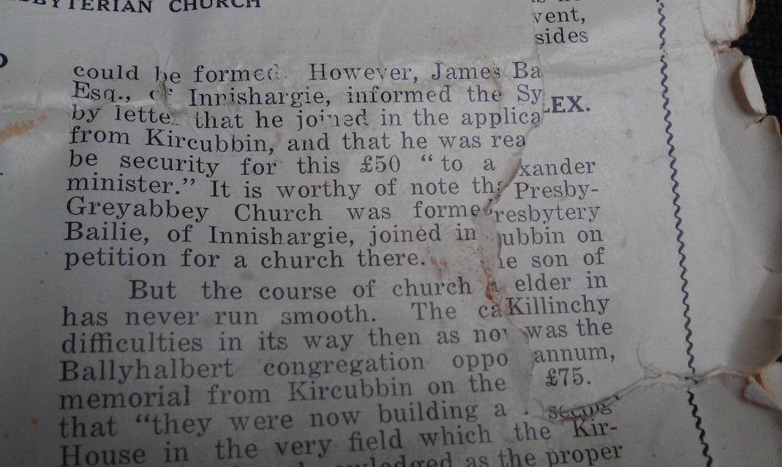

Page 2:
